Technical Specifications –

|  |  |
| --- | --- |
| Reference document | <https://teams.microsoft.com/_#/xlsx/viewer/aggregatefiles/https%3A~2F~2Fpsacunionafpc.sharepoint.com~2Fsites~2FHRMS-Workforce~2FShared%2520Documents~2FWorkForce~2F2.0%2520Deliverables~2F2.0%2520SDDs~2FSolution%2520Design%2520Document%2520-%2520PSAC%2520-%2520Interfaces%2520V2.0.xlsx?baseUrl=https%3A~2F~2Fpsacunionafpc.sharepoint.com~2Fsites~2FHRMS-Workforce&fileId=dcc48d2b-d24c-4636-bef3-98eadb71f467&viewerAction=view> |
| Version | 1.0 |
| Date created | 19-12-2018 |

Document Information

|  |  |
| --- | --- |
| **Client** | PSAC |
| **Project code** | NA |
| **Ticket #** | NA |

SUMMARY DESCRIPTION OF THE REQUEST & SOLUTION

|  |  |  |  |  |  |  |  |  |  |  |  |  |  |  |  |  |  |  |  |  |  |
| --- | --- | --- | --- | --- | --- | --- | --- | --- | --- | --- | --- | --- | --- | --- | --- | --- | --- | --- | --- | --- | --- |
| |  |  |  |  |  |  |  |  |  |  |  | | --- | --- | --- | --- | --- | --- | --- | --- | --- | --- | --- | | This will insert or update the WorkForce cost center details with the latest activity/cost center information from successfactors. |  |  |  |  |  |  |  |  |  |  |   This is the copy of the SuccessFactors Employee Central data and will be updated with the Detla changes after first execution. |  |  |  |  |  |  |  |  |  |  |

Document history

|  |  |  |  |
| --- | --- | --- | --- |
| **Version** | **Author** | **Reason for change** | **Date** |
| 1.0 | Sidhartha Mudrakola | Initial Draft | 19-12-2018 |
|  |  |  |  |
|  |  |  |  |
|  |  |  |  |

Approval and distribution

|  |  |  |  |  |
| --- | --- | --- | --- | --- |
| **Approved by** | **Name** | **Version** | **Signature** | **Date** |
|  |  |  |  |  |
|  |  |  |  |  |
|  |  |  |  |  |

Table of Contents

Technical Specifications – 1

Document Information 1

SUMMARY DESCRIPTION OF THE REQUEST & SOLUTION 1

Document history 2

Approval and distribution 2

Table of Contents 3

1 General information 5

2 Issue 5

3 Interface monitoring 5

3.1 Interface classification 5

4 Requirements related to the interface functionality 6

4.1 Justifications and business requirements 6

4.2 Process flow / Data flow and operational and date-related rules 6

4.3 Assumptions 7

4.4 Constraints 7

4.5 Out of scope 7

5 Requirements related to interface data 7

5.1 Disposition of source interface data 7

5.2 Disposition of target interface data 7

5.3 Mapping source/target data 7

5.4 Data sample 8

5.5 Data retention 8

6 Source / Target Technical Details 8

6.1 Custom Objects 8

6.2 security/permission requirements 8

6.2.1 Tables 8

6.2.2 Programs 8

6.2.3 Permission object 8

6.3 Language of text 9

6.4 Error management 9

7 Solution with Middleware ( HCI / Boomi / PO / PI) 9

7.1 Solution with middleware 9

7.2 Connector type 9

7.3 Mapping rules and conversion criteria 9

8 Configuration and dependencies 9

8.1 Conversion / switchover / other project tasks 9

8.2 Other dependencies 9

9 Interface controls 10

9.1 Completion indicator 10

9.2 Execution accuracy control 10

9.3 Control of duplicate posts 10

9.4 Error detection and communications control 10

9.5 Control of data conversion integrity 10

9.6 Control of the standard file format 10

9.7 Interface data security 10

10 Capture of various data 10

10.1 Other relevant details 10

11 Recovery and reboot 11

12 Test scenarios 11

General information

|  |  |
| --- | --- |
| Description | Update/Load cost center from SF to WFS |
| Tool | HCI |
| Source | SuccessFactors Employee Central |
| Target | Workforce Software |
| SAP pack | N/A |
| Complexity | |  |  |  |  | | --- | --- | --- | --- | |  | Very high | Based on complexity estimator | | |  | High | Based on complexity estimator | | | X | Moderate | Based on complexity estimator | | |  | Low | Based on complexity estimator | | |  | Other | Specify: |  | |  | | | |

Issue

N/A

Interface monitoring

HCI Message monitering

Interface classification

|  |  |
| --- | --- |
| Interface name | Employee Central Cost Center to LD WorkForce |
| Type  frequency | |  |  |  |  | | --- | --- | --- | --- | |  | Batch | Unidirectional transfer of a set of accumulated data. Usually performed by programmed file transfer. | | |  | Near real time | Data transfer based on a unidirectional message. Usually triggered by an event. | | |  | Real time | Immediate transfer of a small data set. Usually triggered by an event. | | |  | Excel upload | Invoked manually from an SAP session. File of local spreadsheet uploaded from a PC. | | | X | Other | Specify: |  | |  | | | |
| Interface  frequency | |  |  |  |  | | --- | --- | --- | --- | |  | Hourly | Details: |  | |  | Daily | Details: |  | |  | Weekly | Details: |  | |  | Monthly | Details: |  | |  | Quarterly | Details: |  | |  | Yearly | Details: |  | | X | On demand | Frequency: |  | | X | Other | Specify: |  | |  | | | |
| Post type submitted | |  |  |  |  | | --- | --- | --- | --- | |  | Complete | Submit all the posts on each execution. | | |  | Edited post | Submit the posts only if one or more fields was (were) edited during the last execution. | | | X | Edited posting data | Submit only the fields and keys that change during the last execution. | | |  | Other | Specify: |  | |  | | | |
| Volume  *(by execution)* | |  |  | | --- | --- | | Average volume: |  | | Peak volume: |  | |

Requirements related to the interface functionality

Trasnfer cost center data from Successfactors employee central to Workforce software.

Justifications and business requirements

NA

Process flow / Data flow and operational and date-related rules



Assumptions

|  |
| --- |
|  |
| Successfactors Employee Central Dev is the gold system and all the required parameters in this integration are referred or analyzed from Successfactors Dev. |
|  |
|  |
|  |
|  |

Constraints

N/A

Out of scope

N/A

Requirements related to interface data

Disposition of source interface data

The source data is available in the form of (type X for ***all*** the items that apply):

|  |  |  |  |
| --- | --- | --- | --- |
|  | Database | Name(s) of table(s): | < Indicate the table name> |
|  | File | Type: | TXT file |
|  | Procedure | Name: | <Enumerate the functions, transactions or other procedure calls that can provide this data set> |
| X | Other | Method: | Successfactors Web Service |

Disposition of target interface data

|  |  |  |  |
| --- | --- | --- | --- |
| X | Database | Name(s) of table(s): | Workforce DB & Tables |
|  | File | Type: | TXT file |
|  | Procedure | Name: | <Enumerate the functions, transactions or other procedure calls that can provide this data set> |
| X | Other | Method: | Workforce Web Service |

Mapping source/target data

This is end-to-edn Custom integration which retrives data from Successfactors to Workforce software

|  |  |
| --- | --- |
| ExternalCode | Field Name : COST_CENTER , Field Value |
| Description_en_US | Field Name : DESCRIPTION , Field value |
| startDate | Effective_date |
| endDate | End_date |

Data sample

NA

Data retention

|  |  |  |  |
| --- | --- | --- | --- |
|  | None | Data retention is not necessary for this interface. | |
|  | 7 days | | |
|  | 15 days | (by default) | |
|  | 30 days | | |
| X | Other | Specify: |  |
|  | | |

Source / Target Technical Details

DEV : <https://api17.sapsf.com>

QA:

PRD:

Custom Objects

NA.

security/permission requirements

NA

Tables

NA

Programs

NA

Permission object

NA

Language of text

English

Error management

HCI Monitor Message Processing

Solution with Middleware ( HCI / Boomi / PO / PI)

Solution with middleware

HCI

Connector type

**Dev:**

* SuccessFactors oData api
  + https://api17.sapsf.com/odata/v2/FOCostCenter
* WFS SOAP Service
  + https://psac-dev.wfsaas.ca/workforce/services/E2G_importLDData?wsdl

Mapping rules and conversion criteria

Custom mapping as stated in Mapping section

Configuration and dependencies

N/A

Conversion / switchover / other project tasks

N/A

Other dependencies

N/A

Interface controls

Completion indicator

In the message monitoring,we will be able to see job status .

Execution accuracy control

Proccessed,Invalid,missing mandatory and warning records are stored in Variables as a text files.

Which can be downloaded from HCI manage Variables.( to be completed)

Control of duplicate posts

N/A

Error detection and communications control

|  |  |
| --- | --- |
| Message Monitoring |  |

Control of data conversion integrity

N/A

Control of the standard file format

N/A

Interface data security

N/A

Capture of various data

N/A

Other relevant details

N/A

Recovery and reboot

NA

Test scenarios

Successfully transferred an Cost center details from SFEC to WFS

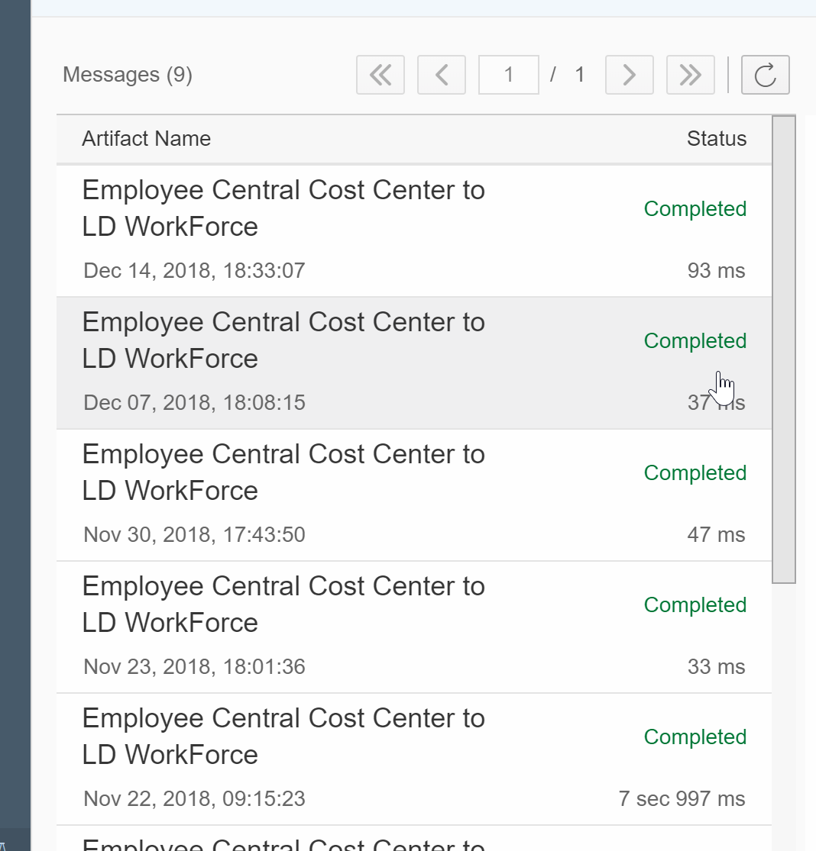

<ns:E2G_importLDDataResponse xmlns:ns="http://services.workforcesoftware.com/xsd" xmlns:soapenv="http://schemas.xmlsoap.org/soap/envelope/">

<ns:return xmlns:ax232="http://ws.apache.org/axis2/xsd" xmlns:ax234="http://webservices.workforcesoftware.com/xsd" xmlns:xsi="http://www.w3.org/2001/XMLSchema-instance" xsi:type="ax232:E2G_importLDDataResult">

<ax234:detailedErrorMessage xsi:nil="true"/>

<ax234:operationSuccessful>true</ax234:operationSuccessful>

<ax234:resultCode>0</ax234:resultCode>

<ax234:resultDescription>Labor Distribution data received. Total records: 60, errors: 0</ax234:resultDescription>

<ax232:result xsi:type="ax232:E2g_ld_import_response">

<ax232:responseDateTime>2018-11-22T14:15:23Z</ax232:responseDateTime>

<ax232:responseOutput xsi:nil="true"/>

<ax232:successful>true</ax232:successful>

</ax232:result>

</ns:return>

</ns:E2G_importLDDataResponse>